 

**GOVERNMENT OF TAMILNADU**

DIRECTORATE OF TECHNICAL EDUCATION, CHENNAI NAAN MUDHALVAN SCHEME (TNSDC) SPONSORED STUDENTS DEVELOPMENT PROGRAMME

ON

**IoT AND ITS APPLICATIONS HOST INSTITUTION**

xxxxx COIMBATORE – 04

**TRAINING PARTNER**

ENTHU TECHNOLOGY SOLUTIONS INDIA PVT LTD

DATE:

|  |  |
| --- | --- |
| Name | Roll No |
| Name 1 | 1 |
| Name 2 | 2 |
| Name 3 | 3 |
| Name 4 | 4 |
| Name 5 | 5 |

# Table Of Contents

|  |  |  |
| --- | --- | --- |
| **S no** | **Title** | **Page no** |
| 1 | Abstract |  |
| 2 | Introduction |  |
| 3 | Hardware and Software Requirements |  |
| 4 | Block Diagram |  |
| 5 | Code |  |
| 6 | Output Results |  |
| 7 | Cloud Output |  |
| 8 | Conclusion |  |

**Abstract**

This project presents a smart irrigation system that automates water pump control based on real-time soil moisture levels, aimed at enhancing water efficiency and reducing manual intervention in agricultural practices. The system is built using an ESP32 microcontroller, an analog soil moisture sensor, and a relay module to control the water pump. The soil moisture sensor continuously monitors the moisture content of the soil, and when the soil is detected as dry (below a predefined threshold), the relay triggers the pump to irrigate the soil. Once the moisture level reaches the desired level, the pump is automatically turned off, preventing over-watering and conserving water.

The system is integrated with IoT functionality using the ThingzMate cloud platform, enabling remote monitoring and control. Users can track real-time soil moisture levels and pump status via the cloud, receive notifications, and adjust system settings remotely. This feature enhances convenience, particularly for large-scale agricultural fields or gardens where manual monitoring is impractical.

In addition to water conservation, this project promotes sustainable agricultural practices by ensuring that crops receive optimal water supply, improving crop yield and reducing water waste. The use of the ESP32 microcontroller also allows for future scalability, such as integrating additional sensors (e.g., temperature, humidity) or expanding the system to support multiple irrigation zones.

The project is implemented using easily accessible and cost-effective components, with programming done through the Arduino IDE. This makes it a viable solution for a wide range of users, from hobbyists to farmers seeking to optimize their irrigation practices through technology.

# Introduction

Efficient water management is a critical concern in modern agriculture, especially in regions facing water scarcity and unpredictable weather patterns. Traditional irrigation methods often lead to either over-watering or under-watering, which can harm crops, waste resources, and reduce overall agricultural productivity. To address these challenges, there is a growing need for automated irrigation systems that can precisely manage water usage based on real-time environmental conditions.

This project introduces a smart irrigation system that automates the control of a water pump using a soil moisture sensor, an ESP32 microcontroller, and a relay module. The system is designed to monitor the soil's moisture levels continuously and activate the water pump only when necessary, ensuring that crops receive the optimal amount of water. By automating this process, the system reduces manual labor, minimizes water wastage, and improves crop health.

Incorporating Internet of Things (IoT) technology, the system is connected to the ThingzMate cloud platform, enabling remote monitoring and control. Users can access real-time data on soil moisture levels, receive notifications, and manage the system from anywhere, adding convenience and flexibility to the irrigation process. This integration not only enhances the system's functionality but also opens up possibilities for future scalability and additional features.

This project demonstrates a practical application of IoT and automation in agriculture, providing a cost-effective and user-friendly solution for small-scale gardeners and large-scale farmers alike. By leveraging technology, the smart irrigation system promotes sustainable farming practices and contributes to the efficient use of water resources, which is increasingly important in today's environmentally conscious world.

# Hardware and Software Requirements

**Hardware Requirements**

1. ESP32 Microcontroller
2. Analog soil moisture sensor with ADC
3. Relay Module
4. USB Cable
5. Jumper Wires

# Software Requirements

1. Wokwi Simulator
2. Arduino IDE
3. Thingzmate Cloud

## ESP32 Microcontroller

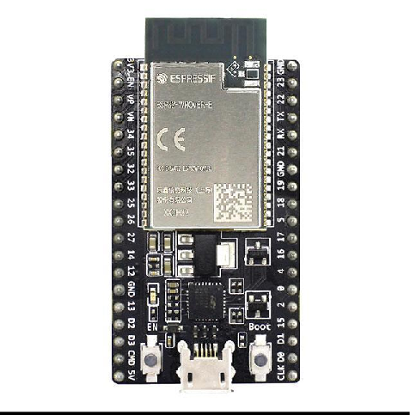

The ESP32 microcontroller is a powerful and versatile chip used in this project to control the four-way traffic light system. It features integrated Wi-Fi and Bluetooth capabilities, allowing for seamless communication with the ThingzMate Cloud for remote monitoring and control. With its dual-core processor and multiple GPIO pins, the ESP32 efficiently handles the timing and sequencing of the traffic lights, making it ideal for real-time IoT applications

## SOIL MOISTURE SENSOR

## An analog soil moisture sensor is a simple and cost-effective tool used to measure the water content in soil. It typically consists of two conductive probes that are inserted into the soil. When the soil is wet, it conducts electricity more effectively, allowing the sensor to output a lower resistance, resulting in a higher analog signal. Conversely, when the soil is dry, the resistance increases, and the analog signal decreases.

## Key Features of an Analog Soil Moisture Sensor:

## Analog Output: The sensor provides an analog voltage output that corresponds to the soil's moisture level. This output can be read by an analog input pin on a microcontroller like the ESP32, allowing for real-time monitoring of soil conditions.

## Simple Design: The sensor generally consists of two metal probes that detect the moisture level through changes in resistance between the probes. The simplicity of the design makes it easy to use and integrate into various projects.

## Calibration: Analog soil moisture sensors often require calibration to define specific moisture levels (e.g., dry, moist, and wet). The calibration process involves measuring the sensor output in both dry and fully saturated soil and determining the appropriate threshold values for automation.

## Cost-Effective: These sensors are relatively inexpensive, making them ideal for hobbyist projects or large-scale applications where multiple sensors are needed.

## Applications: Analog soil moisture sensors are widely used in automated irrigation systems, environmental monitoring, and gardening applications. They are particularly useful in projects where continuous monitoring of soil moisture levels is required to optimize water usage.

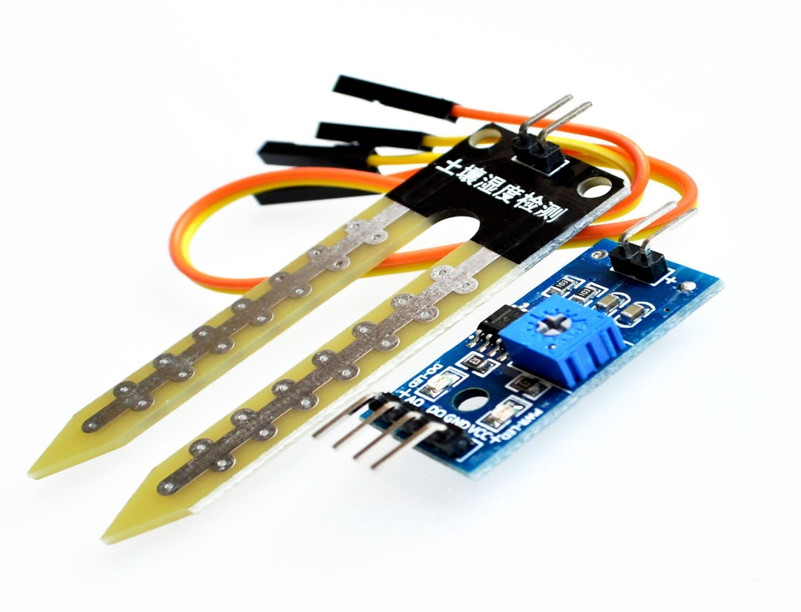

**RELAY MODULE**

A relay module is an electronic device used to control high-current or high-voltage loads with a low-current control signal, such as that from a microcontroller or other low-power digital device. It acts as an electrically operated switch that can turn on or off a larger load (like a motor, lamp, or appliance) based on a signal received from a microcontroller or other control system.

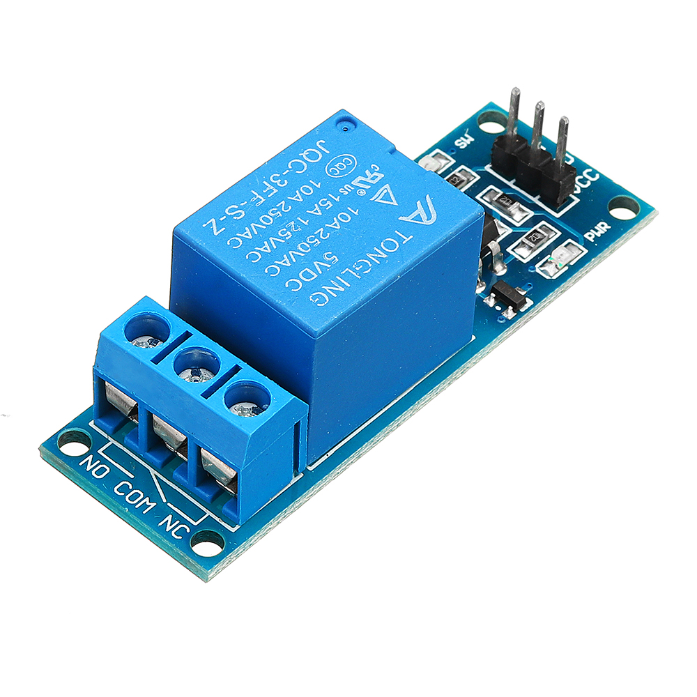

# USB-Cable

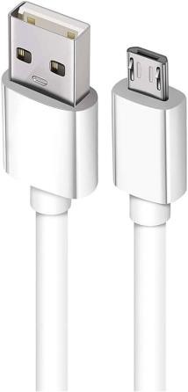

The USB cable is a critical tool in this project, used to connect the ESP32 microcontroller to a computer for power supply, programming, and debugging. It enables the transfer of code and data between the development environment and the microcontroller, facilitating the upload of firmware and real-time communication during the development process. The USB connection also allows for serial monitoring, providing valuable insights into the system's performance and behavior.

# Jumper Wires

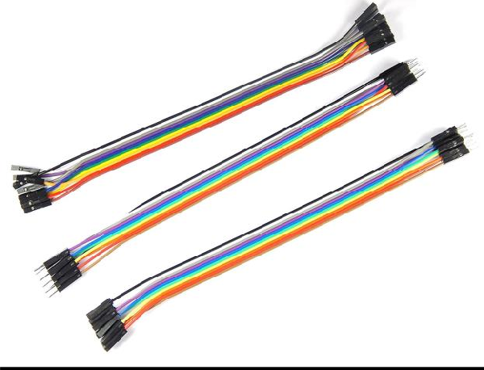

Jumper wires are essential in this project, used to connect the ESP32 microcontroller to the components on the breadboard. These wires provide a flexible and reliable way to link the microcontroller’s GPIO pins to the LEDs, resistors, and other circuit elements, enabling proper signal and power flow. Their ease of use allows for quick modifications and testing during the prototyping stage.

# Wokwi Simulator

Wokwi Simulator is a powerful online tool used in this project to simulate the four-way traffic light controller system before physical implementation. It allows for the virtual testing of the ESP32 microcontroller, LEDs, and other components, enabling real-time visualization and debugging of the circuit and code. By using Wokwi, developers can ensure the system's functionality and make necessary adjustments without needing the actual hardware setup.

# Arduino IDE

Arduino IDE is the primary development environment used in this project for programming and uploading code to the ESP32 microcontroller. It provides an easy-to- use interface for writing, compiling, and debugging the code that controls the four-way traffic light system. With its extensive library support and compatibility with ESP32, the Arduino IDE streamlines the development process, allowing for efficient code iteration and testing.

# Thingzmate Cloud

ThingzMate enables real-time simulation of a 4-way traffic light control system, allowing you to monitor and manage traffic lights via cloud connectivity.It provides tools for configuring traffic light sequences, ensuring accurate simulation of traffic flow and light transitions.With ThingzMate, you can easily visualize and control traffic light statuses, optimizing traffic management and ensuring efficient simulation scenarios.

# Block Diagram

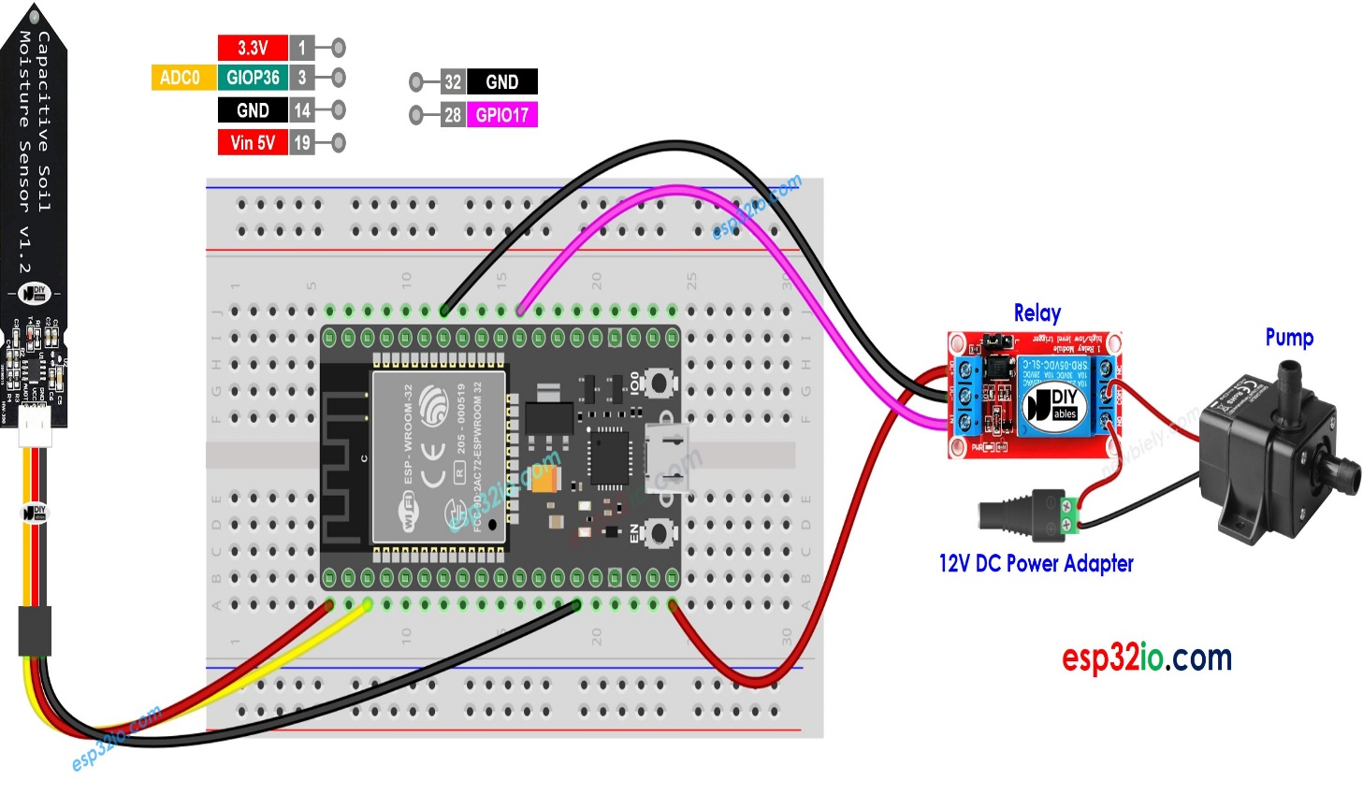

**Code**

#include <WiFi.h>

#include <HTTPClient.h>

// WiFi credentials

#define WIFI_SSID "YOUR DEVICE NAME"

#define WIFI_PASSWORD "YOUR PASSWORD"

// Define the soil moisture sensor pin (Analog pin)

#define SOIL_MOISTURE_PIN 34 // Adjust as per your wiring

// Define the relay pin

#define RELAY_PIN 5 // You can change this to any other GPIO pin

// Server endpoint and Authorization token (Modify these as per your setup)

const char *serverUrl = "https://console.thingzmate.com/api/v1/device-types/soilmoisture/devices/soilmoisture/uplink";

String AuthorizationToken = "Bearer dabe9aa0d02bfc3eb230201ebf623dda";

// Define the soil moisture threshold to control the pump (you may need to calibrate this value)

#define SOIL_MOISTURE_THRESHOLD 500 // Adjust based on your sensor readings

void setup() {

Serial.begin(115200);

// Initialize the relay pin

pinMode(RELAY_PIN, OUTPUT);

digitalWrite(RELAY_PIN, LOW); // Ensure the relay is initially off

// Connect to WiFi

WiFi.begin(WIFI_SSID, WIFI_PASSWORD);

Serial.print("Connecting to WiFi");

while (WiFi.status() != WL_CONNECTED) {

delay(1000);

Serial.print(".");

}

Serial.println("Connected to WiFi");

}

void loop() {

// Read the soil moisture value

int soilMoistureValue = analogRead(SOIL_MOISTURE_PIN);

Serial.print("Soil Moisture Value: ");

Serial.println(soilMoistureValue);

// Control the relay based on soil moisture level

if (soilMoistureValue < SOIL_MOISTURE_THRESHOLD) {

digitalWrite(RELAY_PIN, HIGH); // Turn the pump ON

Serial.println("Pump ON");

uploadStatus("Pump ON");

} else {

digitalWrite(RELAY_PIN, LOW); // Turn the pump OFF

Serial.println("Pump OFF");

uploadStatus("Pump OFF");

}

delay(1000); // 1 second delay between readings

}

void uploadStatus(String status) {

HTTPClient http;

http.begin(serverUrl);

http.addHeader("Content-Type", "application/json");

http.addHeader("Authorization", AuthorizationToken);

// Create JSON payload

String payload = "{\"status\":\"" + status + "\"}";

// Send POST request

int httpResponseCode = http.POST(payload);

if (httpResponseCode > 0) {

String response = http.getString();

Serial.println("HTTP Response code: " + String(httpResponseCode));

Serial.println(response);

} else {

Serial.print("Error code: ");

Serial.println(httpResponseCode);

}

http.end(); // Free resources

}

**Output Results**

**MOISTURED SOIL – PUMP OFF / RELAY OFF**

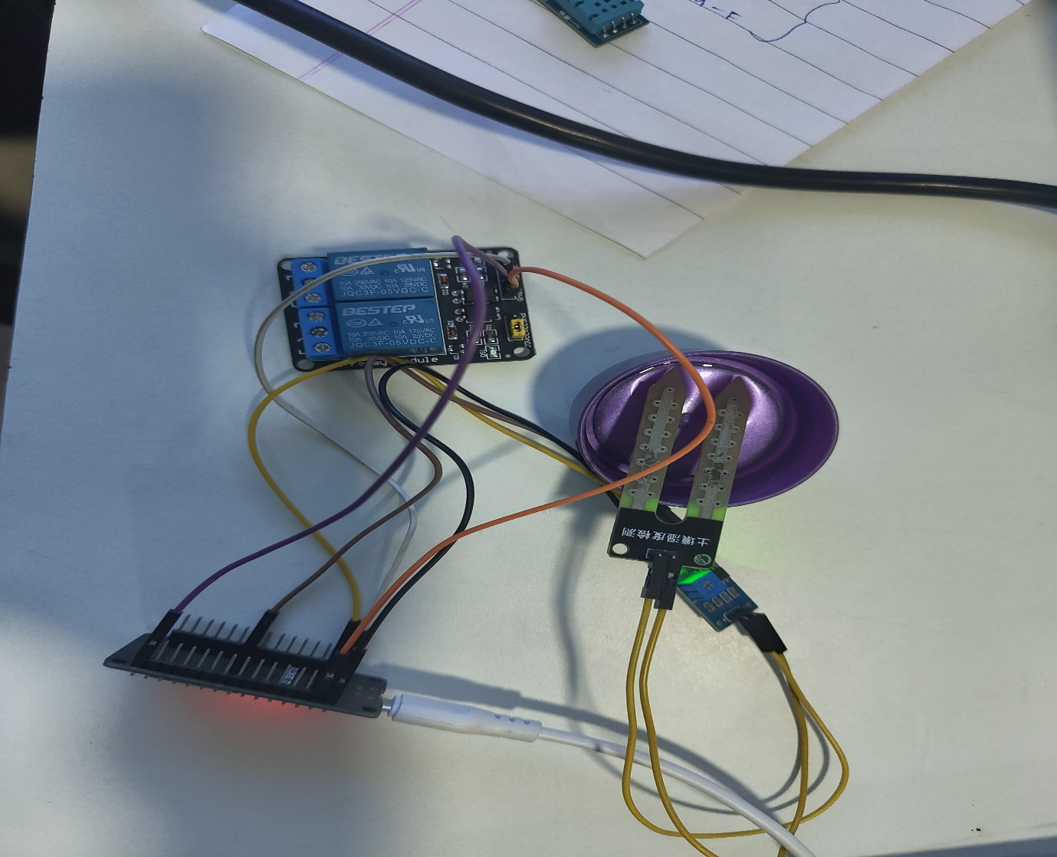

**DRY SOIL – PUMP ON / RELAY ON**

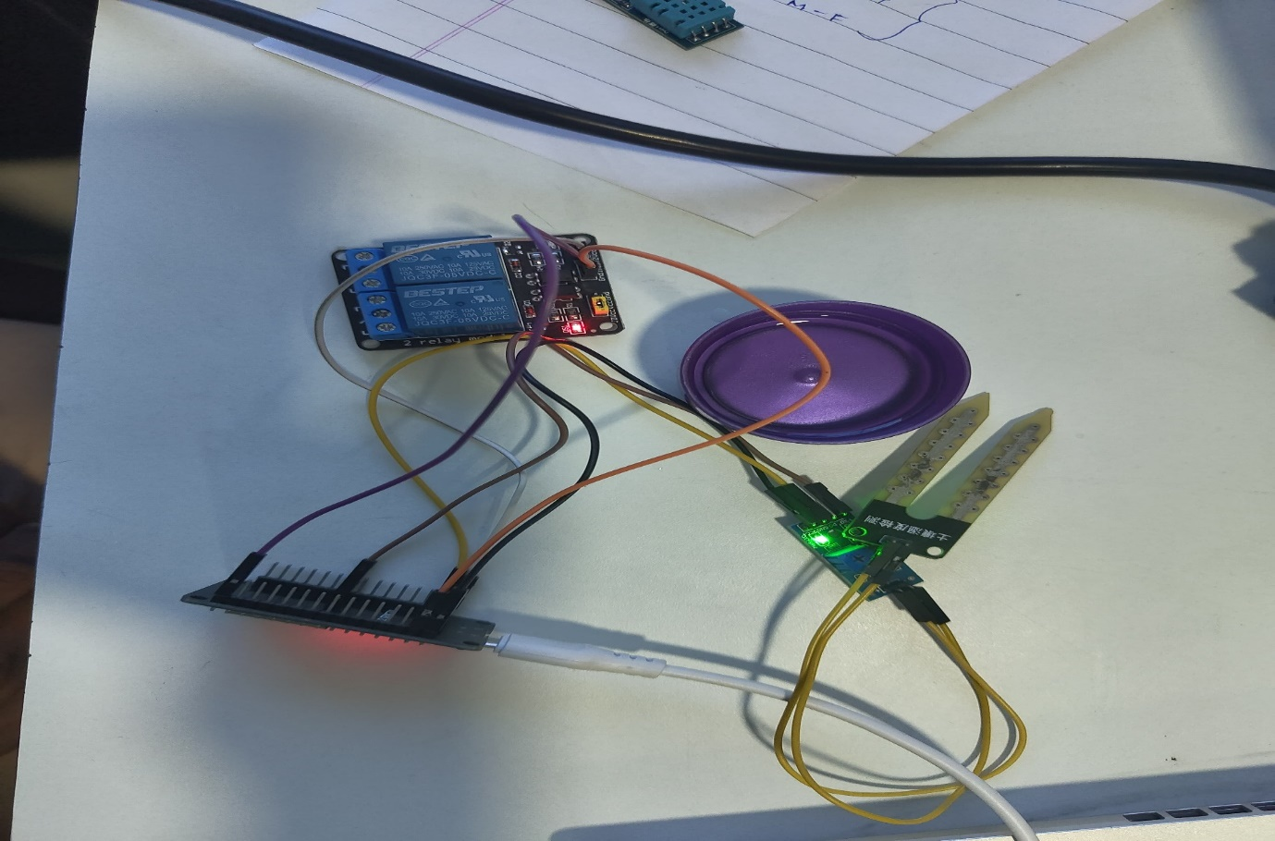

**Cloud Output**

**DRY SOIL – PUMP ON / RELAY ON**

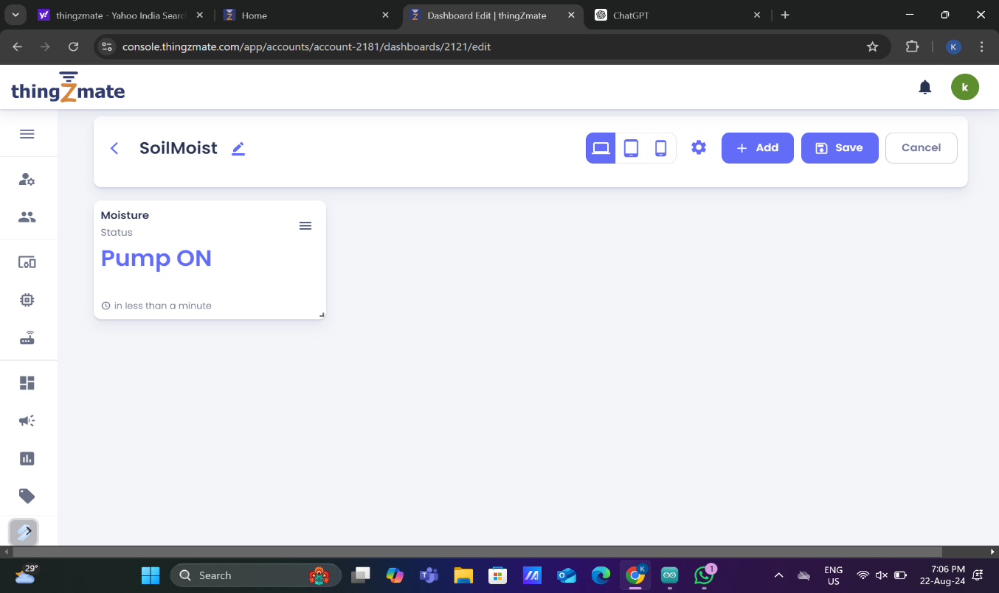

**MOISTURED SOIL – PUMP OFF / RELAY OFF**

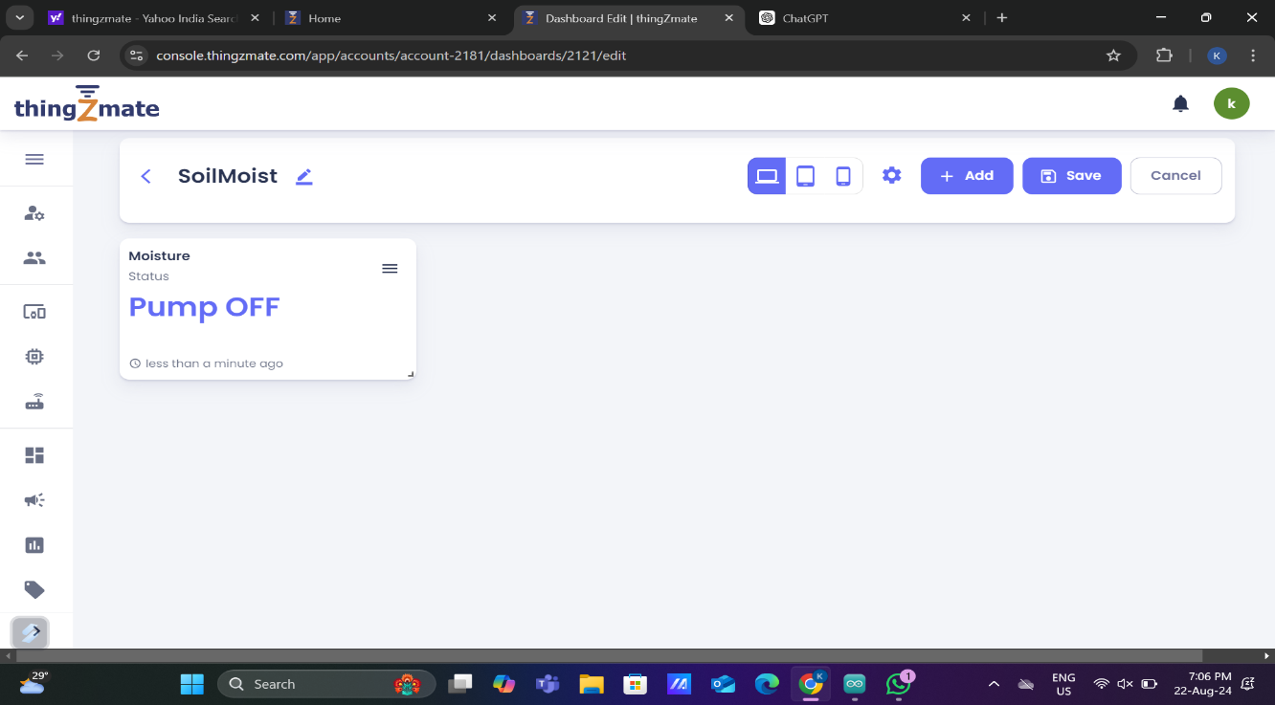

**Conclusion**

The smart irrigation system developed in this project effectively demonstrates how automation and IoT technology can be leveraged to optimize water usage in agriculture. By integrating an analog soil moisture sensor with an ESP32 microcontroller and a relay, the system is capable of monitoring soil moisture levels in real time and controlling a water pump accordingly. This automation ensures that crops receive the right amount of water, reducing waste and improving crop health.

The integration of the ThingzMate cloud platform further enhances the system by allowing remote monitoring and control, making it convenient for users to manage irrigation even from a distance. This feature is particularly beneficial for large agricultural fields or users with multiple gardens, where manual monitoring would be impractical.

Overall, this project presents a cost-effective and scalable solution that addresses key challenges in traditional irrigation practices. It contributes to sustainable farming by promoting efficient water management, which is increasingly important in the context of global water scarcity and climate change. The successful implementation of this system opens the door for further enhancements, such as adding more sensors or expanding the system to cover larger areas, making it a valuable tool for both small-scale gardeners and large-scale farmers.